## **Lab 15 – App Creation**

## Power BI Service – Collaboration and Distribution

You have built the dashboard and are now ready to get feedback and collaborate with your team members.

1. Sign in to PowerBI.com to access your workspace.
2. From the left panel, click **Workspaces**.
3. Click the **ellipsis** next to **DIAD_<youremailaddress>.**
4. Click **Workspace access**.
5. The **Access** dialog opens. Enter the email addresses of the colleagues with whom you want to collaborate. Each user can belong to one of three roles as follows:

|  |  |
| --- | --- |
| Contributor | Add/edit/delete content within workspace. |
| Member | Everything a Contributor can do. Re-share. Publish & update Apps. |
| Admin  Viewer | Everything a member can do. Can change/delete workspace. Can add Admins.  View/interact  Read data stored in workplace Data Flows |

1. Select the appropriate role and then click **Add**.
2. Once you have finished adding your colleagues, click **Close**.

**Note**: If you don’t have a colleague’s email please close without submission.

**Note**: You can ask your colleague to login and access the workspace.

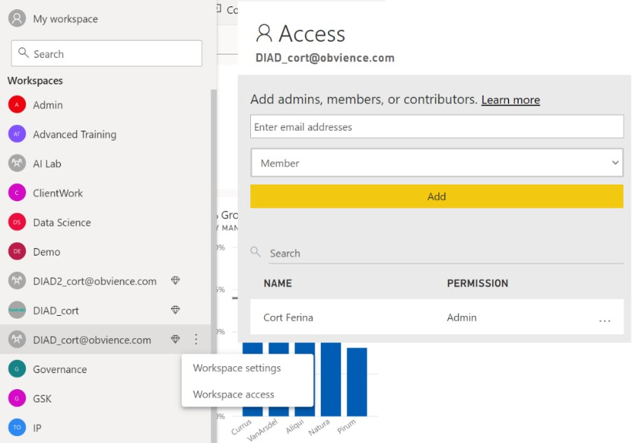

Now let’s share the content we have created with report viewers and consumers. To start, we need to publish an app. An App can include multiple dashboards and reports.

1. In the left panel select the **DIAD_<youremailaddress> workspace**.
2. In the **Dashboard** page, notice there is an option named **Included in App** which can be selected to include the Dashboard in the App.

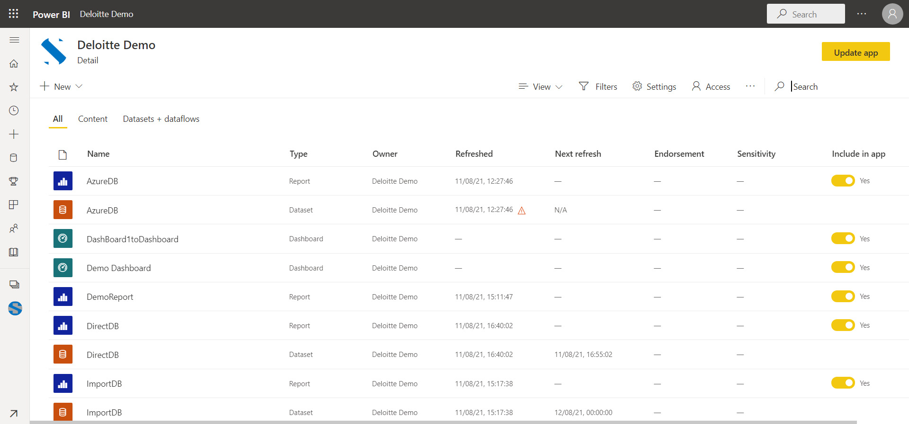

1. Navigate to the **Reports** page.
2. Notice there is an option named **Included in App** which can be selected to include the Reports in the App.

If you have reports and dashboards in your workspace that you do not want to share with report viewers, uncheck this box. In our case we would like to include the DIAD Final Report, so we will leave the box checked. Ensure you have checked the report and not the dataset.

1. In the left panel, click the **DIAD_<youremailaddress>** workspace.
2. In the upper right corner, click the **Create app** button.

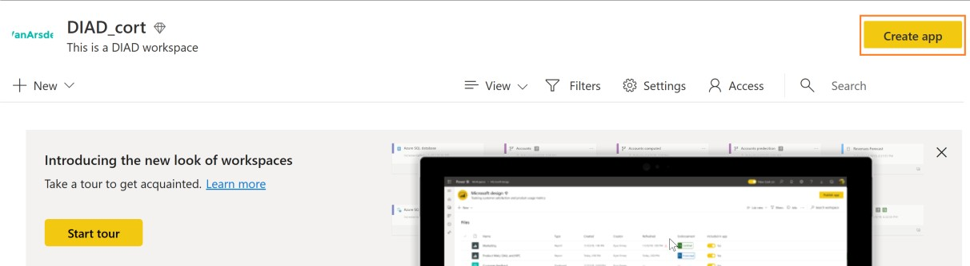

1. In the **Setup** page, type **This is DIAD app** in the description field.

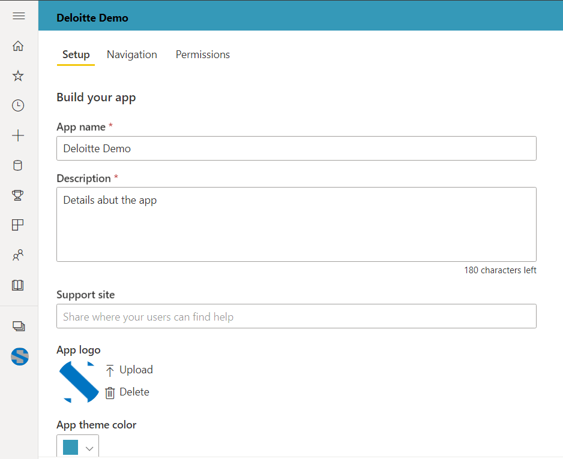

Click the **Navigation** tab.

Add section

Then move Dashboard and report under corresponding sections

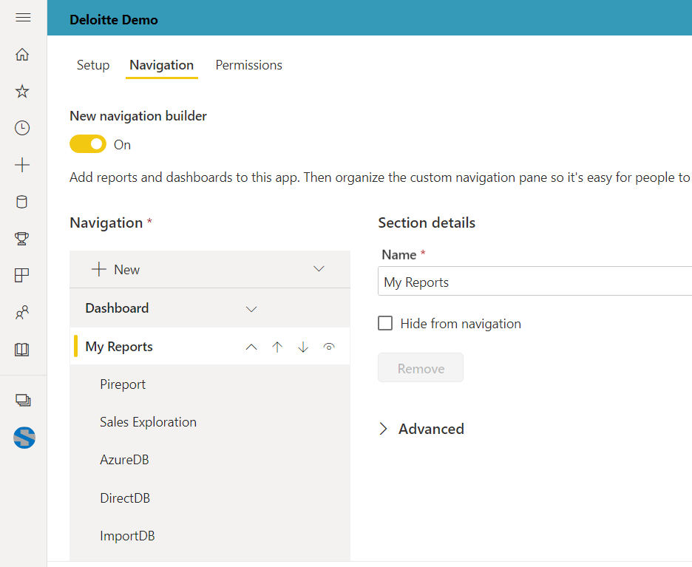

1. From the **Navigation** menu, click **(dashboard)**.
2. When a user accesses the DIAD app, we want them to land on the **VanArsdel** dashboard.
3. Navigate to the **Permissions** page.

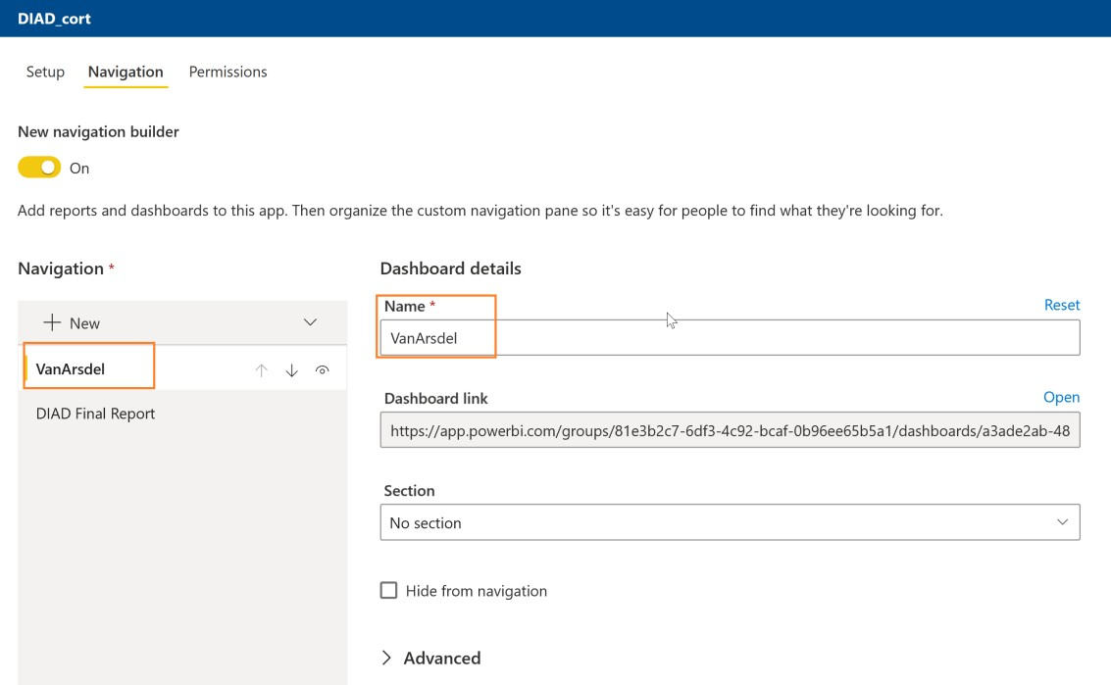

Go to permissions tab

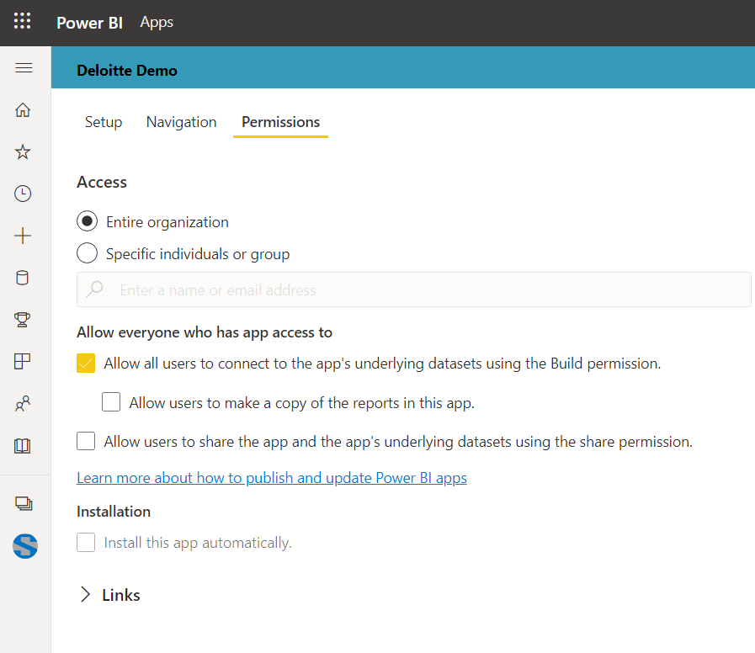

1. Enter the email addresses of the users or groups to whom you want to give access.

**Note**: If you didn’t enter an email address previously, no need to enter one here.

1. On the bottom right corner, click **Publish App**.
2. The **Ready to publish** dialog appears, click **Publish**.
3. Once the App is published a success dialog appears.

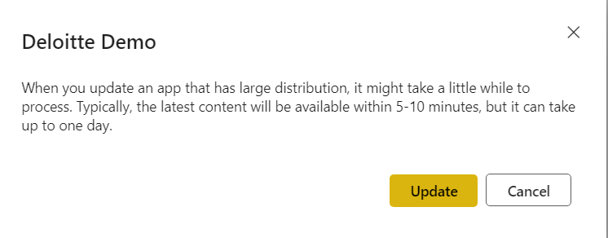

You can copy the link to the App after it’s been successfully published and share it with individuals via email. A better way for report viewers to consume the App is by logging onto Power BI Service and

registering the App.

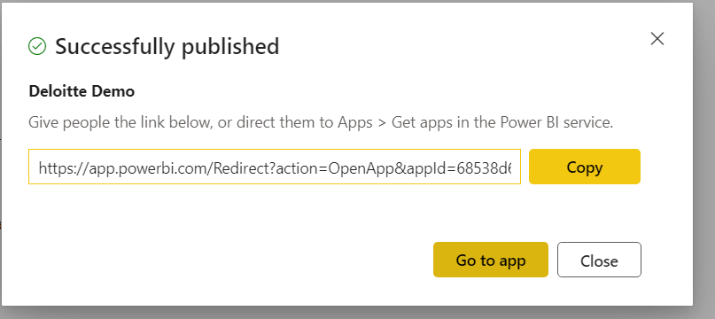

**Official Document**

# Publish an app in Power BI

In Power BI, you can create official packaged content, then distribute it to a broad audience as an app. You [create apps in workspaces](https://docs.microsoft.com/en-gb/power-bi/collaborate-share/service-create-the-new-workspaces), where you can collaborate on Power BI content with your colleagues. Then you can publish the finished app to large groups of people in your organization. The article [Install and use apps with dashboards and reports](https://docs.microsoft.com/en-gb/power-bi/consumer/end-user-app-view) outlines the app user experience.

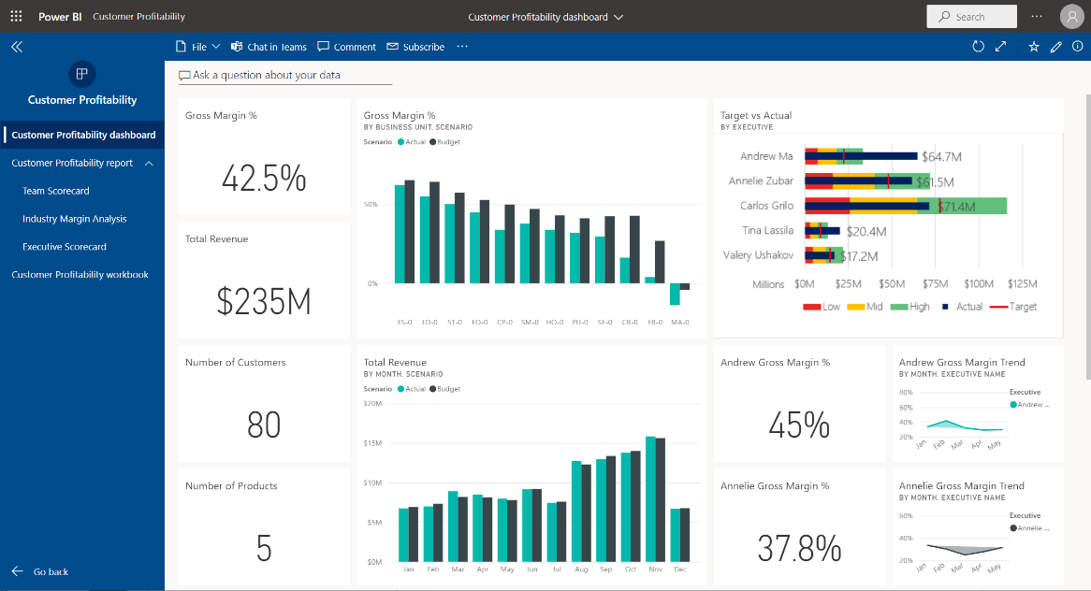

Your business users often need multiple Power BI dashboards and reports to run their business. With Power BI apps, you can create collections of dashboards and reports and publish these collections as apps to your whole organization or to specific people or groups. For you as a report creator or admin, apps make it easier to manage permissions on these collections.

Business users get your apps in a few different ways:

* They can find and install your app from Microsoft AppSource.
* You can send them a direct link.
* You can install it automatically in your coworkers' Power BI accounts if your Power BI administrator gives you permission.
* Power BI does not send any email to internal users when you distribute or update an app. If you distribute it to external users, those users receive an email with a direct link.

You can create the app with its own built-in navigation, so your users can easily find their way around your content. They can't modify the contents of the app. They can interact with it either in the Power BI service, or one of the mobile apps -– filtering, highlighting, and sorting the data. They get updates automatically and you can control how frequently the data refreshes. You can also give them Build permission to connect to the underlying datasets, and to create copies of the reports in the app. Read more about the [Build permission](https://docs.microsoft.com/en-gb/power-bi/connect-data/service-datasets-build-permissions).

## Licenses for apps

To create or update an app, you need a Power BI Pro or Premium Per User (PPU) license. For app consumers, there are two options.

* **Option 1** The workspace for this app is not in a Power BI Premium capacity: All business users need Power BI Pro or Premium Per User (PPU) licenses to view your app.
* **Option 2** The workspace for this app is in a Power BI Premium capacity: Business users without Power BI Pro or Premium Per User (PPU) licenses in your organization can view app content. However, they can't copy the reports, or create reports based on the underlying datasets. Read [What is Power BI Premium?](https://docs.microsoft.com/en-gb/power-bi/admin/service-premium-what-is) for details.

## Publish your app

When the dashboards and reports in your workspace are ready, you choose which dashboards and reports you want to publish, then publish them as an app.

1. In the workspace list view, decide which dashboards and reports you want to **Include in app**.

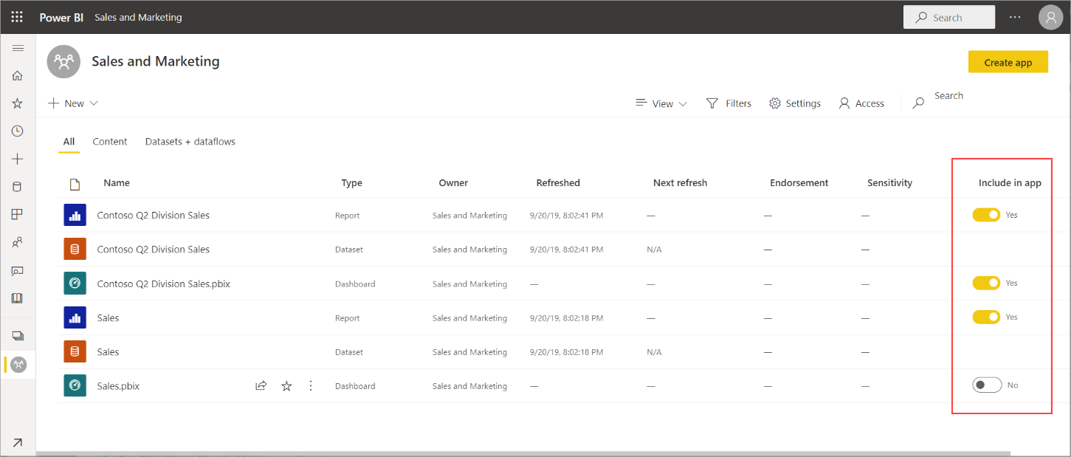

If you choose not to include a report that has a related dashboard, you see a warning next to the report. You can still publish the app, but the related dashboard won't have the tiles from that report.

1. Select the **Create app** button in the upper right to start the process of creating and publishing an app from the workspace.

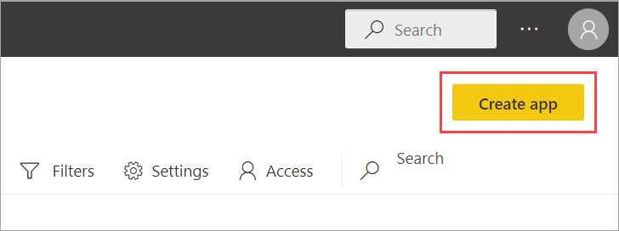

1. On **Setup**, fill in the name and description to help people find the app. You can also set a theme color, add a link to a support site, and specify contact information.

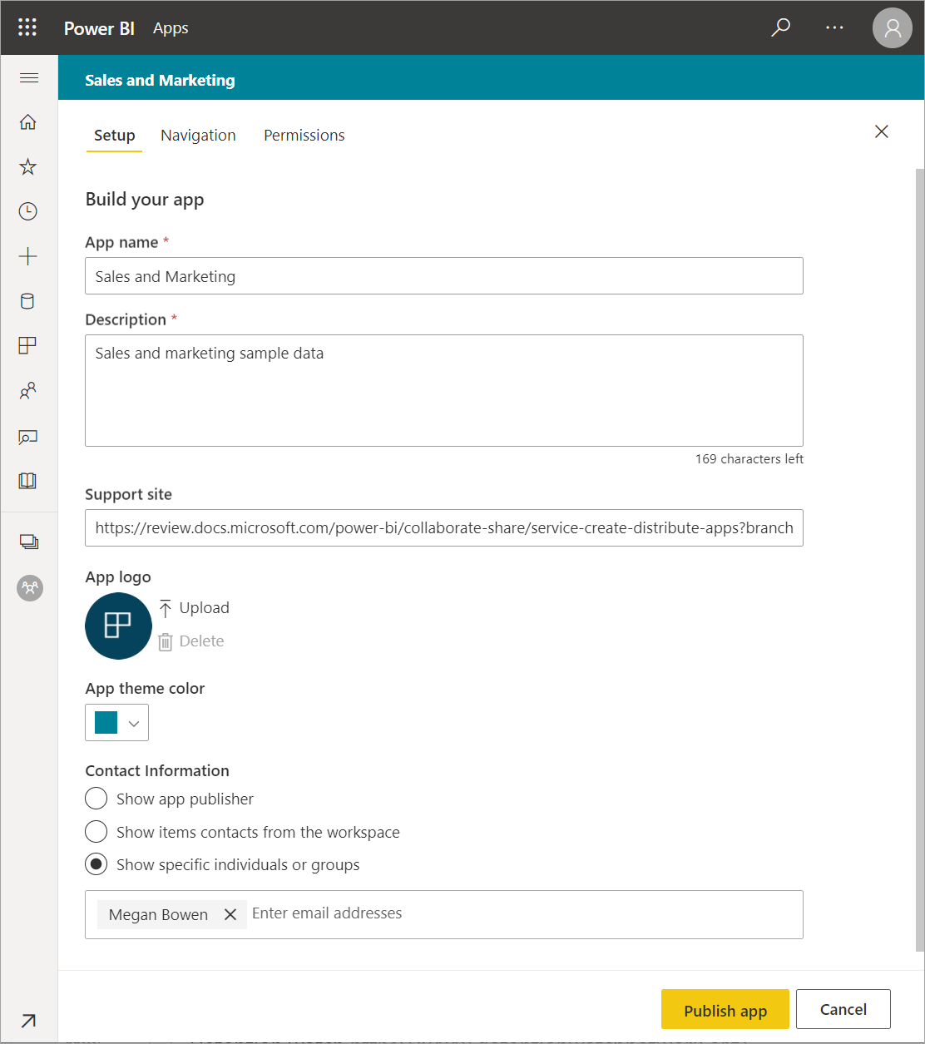

1. On **Navigation**, you select the content to be visible in the app. Then you add app navigation, to organize the content in sections. See [Design the navigation experience for your app](https://docs.microsoft.com/en-gb/power-bi/collaborate-share/service-create-distribute-apps#design-the-navigation-experience) in this article for details. Under **Advanced**, you can set the default width of the left navigation pane.

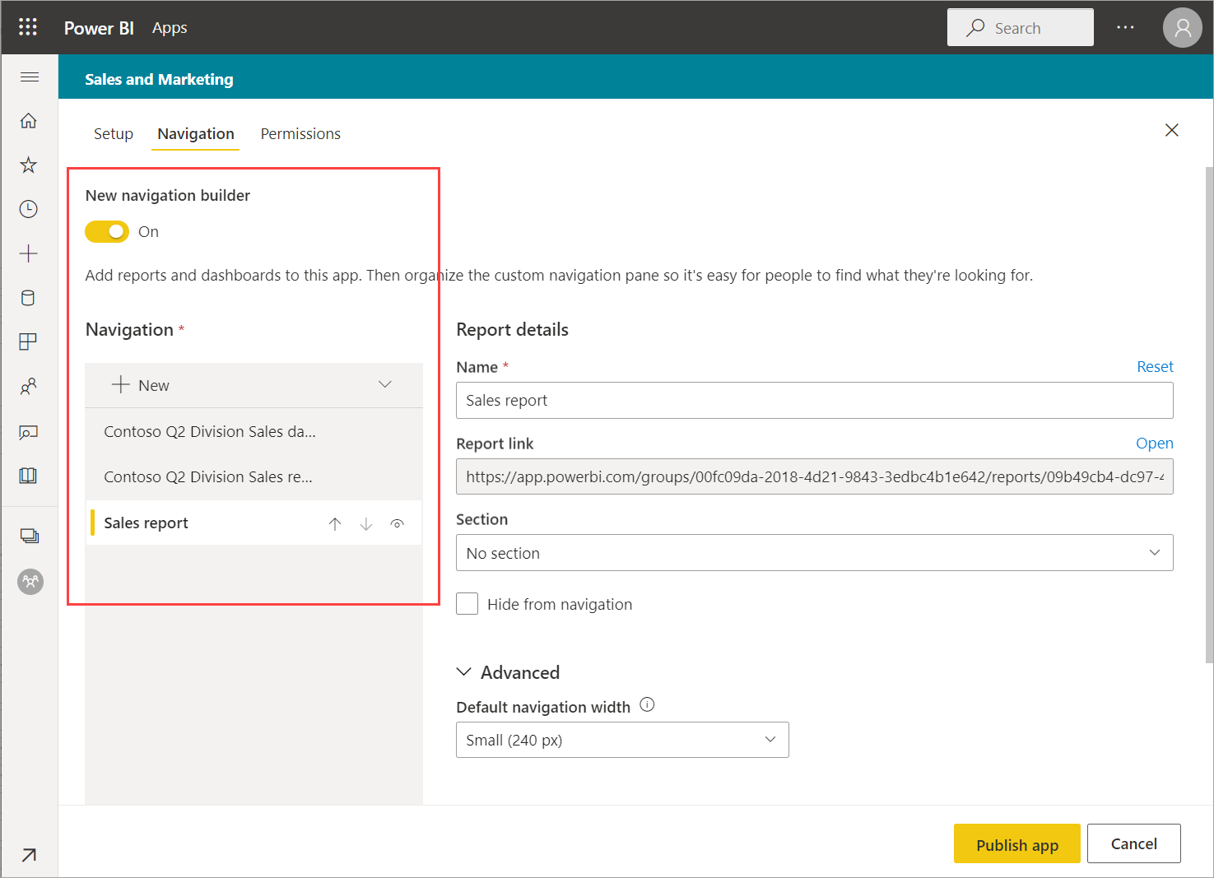

1. On **Permissions**, decide who has access to the app, and what they can do with it.
   * In the [new experience workspaces](https://docs.microsoft.com/en-gb/power-bi/collaborate-share/service-create-the-new-workspaces): specific people, Azure AD security groups and distribution lists, and Microsoft 365 Groups. All workspace users are automatically given access to the app for the workspace.
   * In [classic workspaces](https://docs.microsoft.com/en-gb/power-bi/collaborate-share/service-create-workspaces): everyone in your organization, specific people, or Azure Active Directory (Azure AD) security groups.
   * You can allow app users to connect to the app's underlying datasets by giving them Build permission. They'll see these datasets when they're searching for shared datasets. Read more about [allowing users to connect to the app's datasets](https://docs.microsoft.com/en-gb/power-bi/collaborate-share/service-create-distribute-apps#allow-users-to-connect-to-datasets), in this article.
   * Users with Build permission can also have permission to copy reports from this app to another workspace. Read more about [allowing users to copy reports in the app](https://docs.microsoft.com/en-gb/power-bi/collaborate-share/service-create-distribute-apps#allow-users-to-copy-reports), in this article.

**Important**

If your app relies on datasets from other workspaces, it is your responsibility to ensure all app users have access to the underlying datasets. If the app or report is in the same workspace as the dataset, make sure you add the report associated with the dataset to the app as well.

1. You can install the app automatically for the recipients, if your Power BI admin has enabled this setting for you in the Power BI Admin Portal. Read more about [automatically installing an app](https://docs.microsoft.com/en-gb/power-bi/collaborate-share/service-create-distribute-apps#automatically-install-apps-for-end-users) in this article.

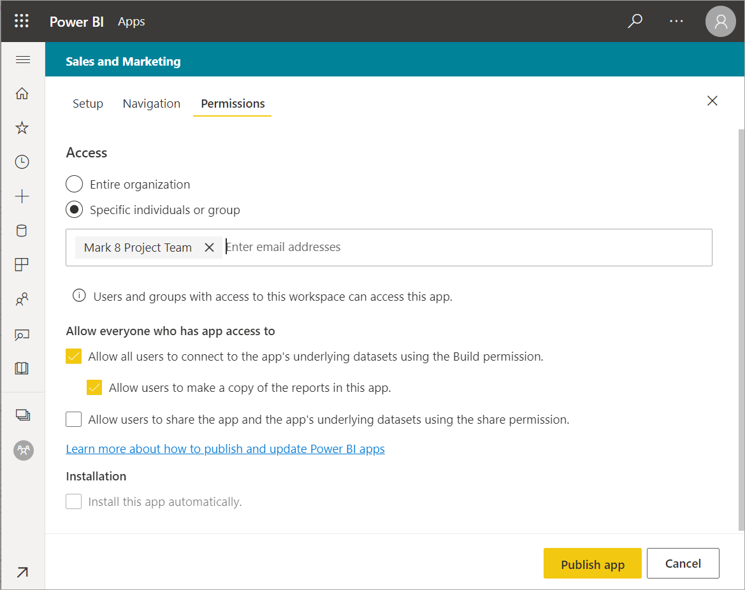

1. When you select **Publish app**, you see a message confirming it's ready to publish. Select **Publish**.
2. In the **Successfully published** dialog box, you can copy the URL that's a direct link to this app.

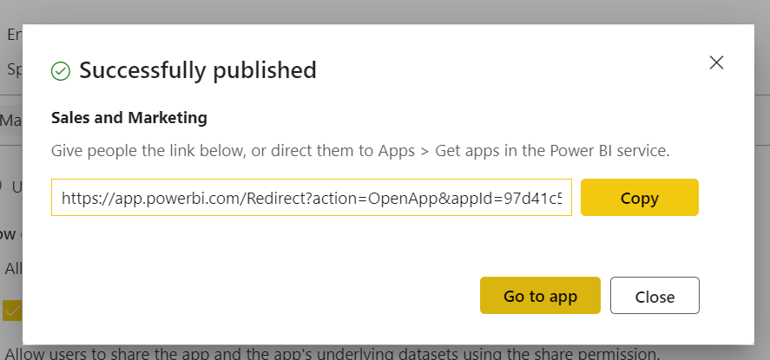

You can send that direct link to the people you've shared it with, or they can find your app on the Apps tab by going to **Download and explore more apps from AppSource**. Read more about the [app experience for business users](https://docs.microsoft.com/en-gb/power-bi/consumer/end-user-apps).